Population Distribution by Gender

The objective of this task is to determine the distribution by gender in a population

Import data

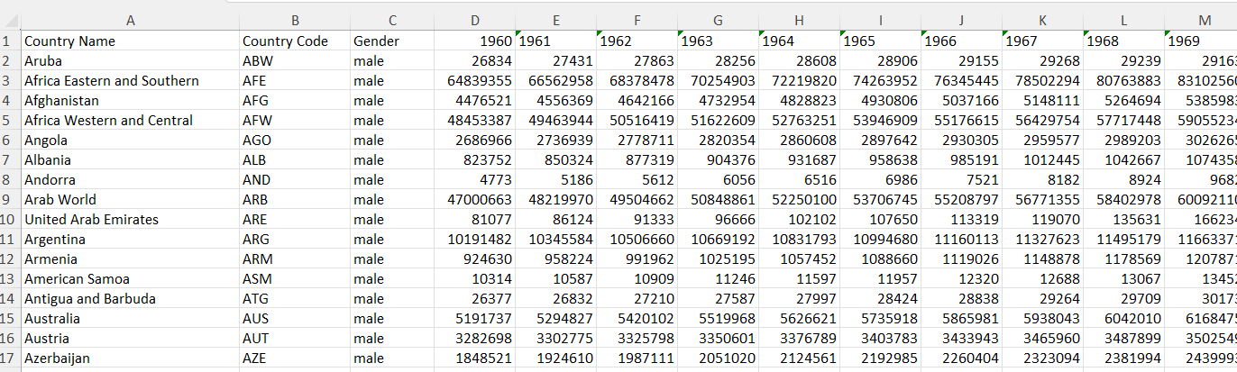

Figure Male datasheet

Different files

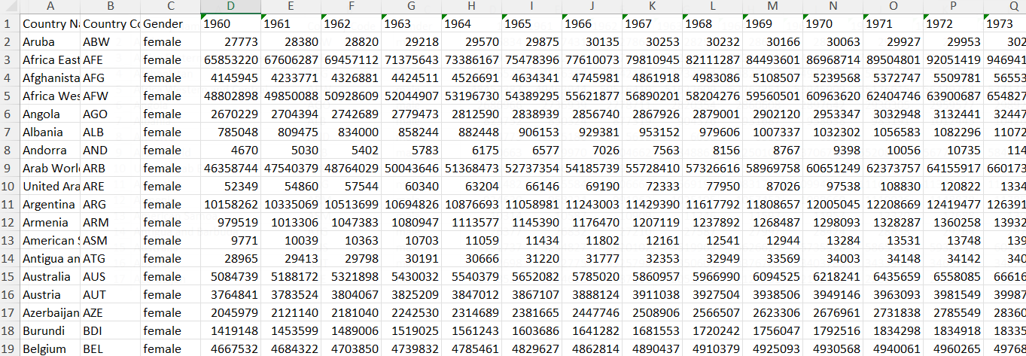

Figure Female datasheet

Understand Data

The metadata file provides valuable information about the data especially the definition of terms, codes, and indicators

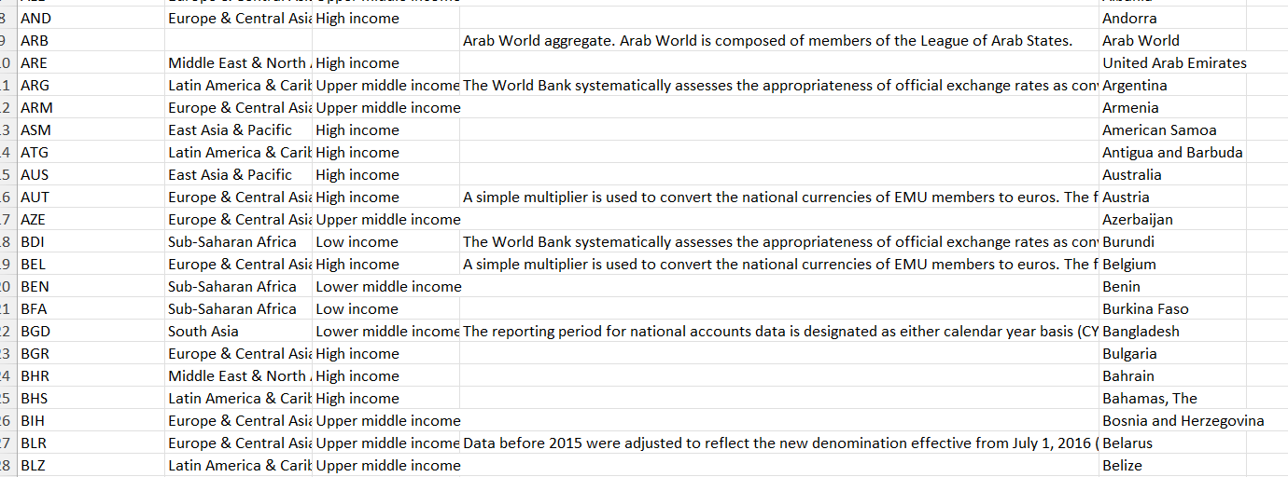

Figure Metadata

Data Cleaning

* Delete empty rows and columns in male and female data sheet
* Delete unnecessary columns, for example, - TOT in male and female data sheets
* Rename gender column in both sheets

Data Merging

* Merge male and female data sheets into one sheet
* Use power query to load both male and female worksheets
* On data tab, click Get Data> From File> From Excel Worksheet>Male, Female, one at a time
* From the get data tab, choose Combine Queries > Append and fill the dialogue box that appears
* The resultant worksheet named Combined Data will have data with 531 rows

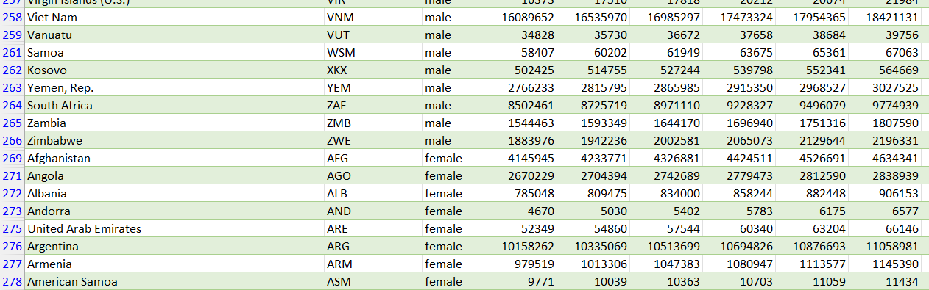

Figure Merged Data

Sort and Filter

* Use filter function to eliminate non-significant groupings such as OECD, Low Income, High Income etc. and remain with country names.
* Use pivot table to determine the sum for both males and females in each country per year between 1960-2023.

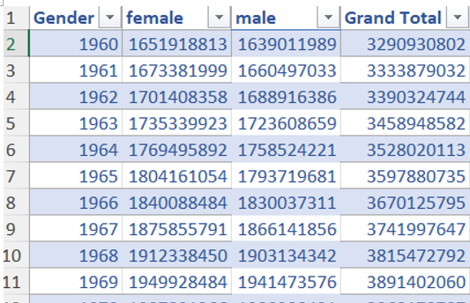

Figure Filtered data

Plot the distribution for male and female with 5-year intervals

Population Growth Chart 1960-2023